Solutions: London Air Quality I
Question 1
# Solution

dataset_aurn_CA1_CLL2 <- importAURN(
site = c("CA1", "CLL2"),
year = 2025,
data_type = "daily",
pollutant = c("pm2.5", "pm10")
)

Note 1: This code should download the datasets for CA1 and CLL2. They need to do this extraction in one line of code – the comment here is about code efficiency and not repeat the same lines of code when it can all be executed in one.
Question 2
Plot 1
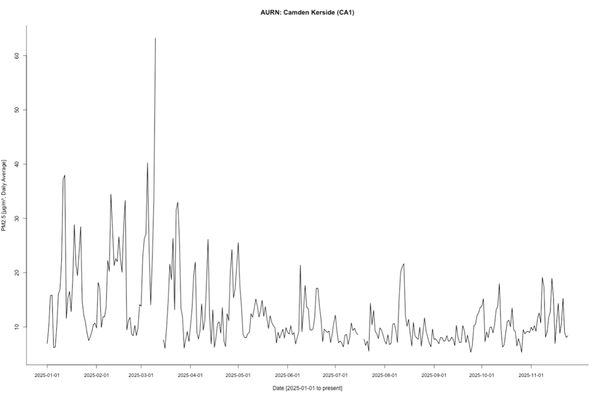
Plot 2
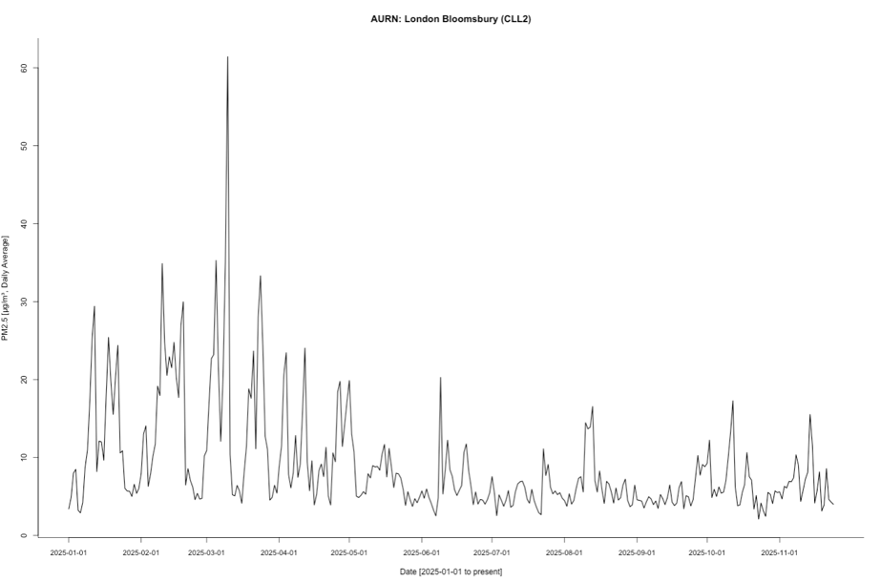
For both CA1 and CLL2, the plots show a time series of daily average PM2.5 concentrations (µg/m³) measured from 1 January 2025 to late November 2025. The patterns are similar. Broadly speaking for both locations, it seems the PM2.5 concentration (µg/m³), daily averages range roughly from 5 to 65 µg/m³. The plots demonstrate seasonal variation, with higher and more erratic PM2.5 concentrations in early spring, followed by lower and more stable levels in summer, and then a rise again in autumn. The single highest value in the series occurs in early March, standing out markedly above the rest.
Notes 1: For Question 2, the task is to generate two separate time-series plots for PM2.5 at sites CA1 and CLL2, as well as providing a joint interpretation of the observed patterns. Here, we were looking for them to report the following characteristics of the plots: the seasonal patterns of PM2.5 represented by the two time series across the date range (e.g. 01/01/2025 to late November 2025 i.e., to date of pulling the records); roughly identifying peaks and “eyeballing” the maximum and minimum values to describe the range of PM2.5 concentrations (e.g. 5 to 65 µg/m³) at the sites; and describing increasing or decreasing trajectories, noting where these trends are most pronounced or decline across winter, spring, summer, or autumn. Because students are pulling the data on different dates expect some plots to be marginally different. The expected interpretation should read something like the above.

Question 3
 | CA1 | CLL2
 | Mean (SD) | Mean (SD)
Overall | 12.49 (±6.86) | 8.97 (±6.94)
Q1 | 17.79 (±9.93) | 14.23 (±10.02)
Q2 | 11.87 (±4.36) | 8.42 (±4.68)
Q3 | 9.14 (±2.96) | 5.81 (±2.51)
Q4 | 10.63 (±3.20) | 6.56 (±3.09)

Overall: CA1 experienced higher average PM2.5 concentrations than CLL2 across the year. Both sites show similar variability as indicated by comparable standard deviations. The higher values at CA1 are consistent with it being a kerbside site, reflecting stronger influence from traffic emissions.

Quarterly: Both sites record their highest PM2.5 levels in Q1, with particularly large variability. But PM2.5 levels drop sharply at both stations in Q2 relative to Q1 showing is smaller variability in its SD. In Q3, it can be inferred that it’s the cleanest quarter for both sites showing the lowest Mean and SD values for PM2.5 in Q3. Lastly, PM2.5 levels begin to rise again heading into autumn, winter and new year.
Note 1: For Question 3, they were expected to report a table summarising both the overall and quarterly mean PM2.5 concentrations (with their standard deviations) for CA1 and CLL2; and then comparing the results by identifying which site shows higher levels of PM2.5 based on the mean, as well as comparing the variability at each site using the standard deviation.
Notes 2: The table summarises the overall and quarterly mean PM2.5 concentrations (with their standard deviations in the round brackets) for the two monitoring stations i.e., CA1 (Camden Kerbside) and CLL2 (London Bloomsbury) during 2025 (so this is based on the dataset they extracted in Question 1). The table needs to look clean like the above with both the mean and SD values reported together side-by-side. The expected interpretation should read something like the above.

Question 4
Notes: Students are given the option to perform this analysis for CA1, or CLL2. The solutions have been provided accordingly for each site.

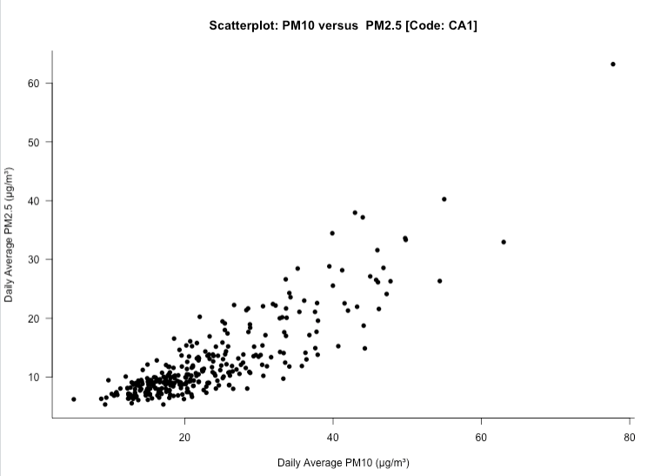

CA1 | Output
Correlation between PM10 & PM2.5 | Correlation: 0.81(p-value < 0.05)
Linear Regression model | Intercept: -0.04531 (p-value = 0.862)  Coefficient for PM2.5: 1.197 (p-value < 0.05)

The scatterplot of daily differences in PM10 versus PM2.5 shows a strong positive linear relationship. As changes in PM2.5 increase, changes in PM10 also increase at CA1. In terms of correlation (0.81, p-value <0.05), there is a strong, statistically significant positive correlation between day-to-day changes in PM10 and PM2.5 concentrations at CA1. When PM2.5 rises or falls from one day to the next, PM10 tends to change in the same direction. Lastly, from the regression model, we can see that each 1 µg/m³ unit change in PM2.5 is associated with a 1.197 µg/m³ change in PM10 on average, which is statistically significant.
Notes 1: For Question 4, based on the selected site, they were expected to generate a scatterplot with PM10 on the y-axis (dependent variable) and PM2.5 on the x-axis (independent variable) to descriptively show how they are related; then perform a correlation analysis to quantify the strength of that relationship and assess whether that strength is statistically significant; and then finally, fit a linear regression model to show how a unit change in the change of PM2.5 (i.e., detrended and autocorrelation removed) impacts the changes in PM10 levels, and whether this effect is statistically significant.
Notes 2: They need to provide an interpretation of the scatterplot, correlation and coefficient of PM2.5. They need to be explicit in showing the results – for instance, the above is specific to site CA1 (if that student selected this). The tone of the interpretation should be something like the above. Outputs i.e., table with correlation and regression estimates must be included along with a scatterplot annotated to that site type.

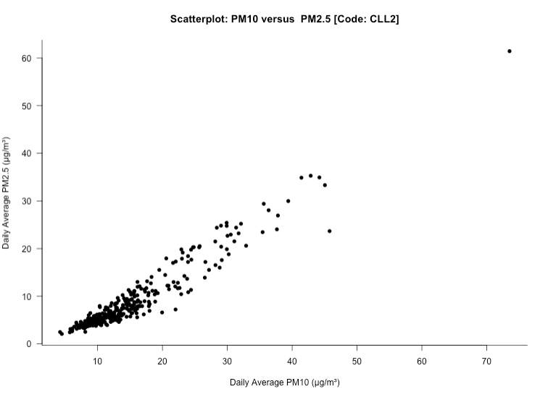
CLL2 | Output
Correlation between PM10 & PM2.5 | Correlation: 0.95 (p-value < 0.05)
Linear Regression model | Intercept: 0.0016 (p-value = 0.989)  Coefficient for PM2.5: 1.181 (p-value < 0.05)

The scatterplot of daily differences in PM10 versus PM2.5 shows a strong positive linear relationship. As changes in PM2.5 increase, changes in PM10 also increase at CLL2.

In terms of correlation (0.95, p-value <0.05), there is a strong, statistically significant positive correlation between day-to-day changes in PM10 and PM2.5 concentrations at CLL2. When PM2.5 rises or falls from one day to the next, PM10 tends to change in the same direction.

Lastly, from the regression model, we can see that each 1 µg/m³ unit change in PM2.5 is associated with a 1.181 µg/m³ change in PM10 on average, which is statistically significant.

Notes 1: For Question 4, based on your selected site, they were expected to generate a scatterplot with PM10 on the y-axis (dependent variable) and PM2.5 on the x-axis (independent variable) to descriptively show how they are related; then perform a correlation analysis to quantify the strength of that relationship and assess whether it is statistically significant; and finally, fit a linear regression model to show how a unit change in PM2.5 impacts PM10 levels, and whether this effect is statistically significant.
Notes 2: Similarly, they need to provide an interpretation of the scatterplot, correlation and coefficient of PM2.5. They need to be explicit in showing the results – for instance, the above is specific to site CLL2 (if that was selected). The tone of the interpretation for that site should be something like the above. Outputs i.e., table with correlation and regression estimates must be included along with a scatterplot annotated to site type.
Appendix: Full R Syntax
library("openair")

## Question 1

dataset_aurn_CA1_CLL2 <- importAURN(
site = c("CA1", "CLL2"),
year = 2025,
data_type = "daily",
pollutant = c("pm2.5", "pm10")
)

## Question 2

dataset_aurn_CA1_CLL2$date_formatted <- as.Date(dataset_aurn_CA1_CLL2$date, format = "%Y-%m-%d")
class(dataset_aurn_CA1_CLL2$date_formatted)

## filter the dataset
dataset_aurn_CA1 <- dataset_aurn_CA1_CLL2[dataset_aurn_CA1_CLL2$code == "CA1",]
dataset_aurn_CLL2 <- dataset_aurn_CA1_CLL2[dataset_aurn_CA1_CLL2$code == "CLL2",]

## plot 1
plot(dataset_aurn_CA1$pm2.5 ~ dataset_aurn_CA1$date_formatted,
type="l",
lwd=1.5,
main="AURN: Camden Kerside (CA1)",
ylab = "PM2.5 [μg/m³, Daily Average]",
xlab = "Date [2025-01-01 to present]",
bty = "L",
xaxt = "n")

axis.Date(
side=1,
at=seq(min(dataset_aurn_CA1$date_formatted), max(dataset_aurn_CA1$date_formatted), by = "months"),
format="%Y-%m-%d",
cex.axis = .9,
labels = TRUE)

## plot 2
plot(dataset_aurn_CLL2$pm2.5 ~ dataset_aurn_CLL2$date_formatted,
type="l",
lwd=1.5,
main="AURN: London Bloomsbury (CLL2)",
ylab = "PM2.5 [μg/m³, Daily Average]",
xlab = "Date [2025-01-01 to present]",
bty = "L",
xaxt = "n")

axis.Date(
side=1,
at=seq(min(dataset_aurn_CLL2$date_formatted), max(dataset_aurn_CLL2$date_formatted), by = "months"),
format="%Y-%m-%d",
cex.axis = .9,
labels = TRUE)

## Question 3

## overall CA1
summary(dataset_aurn_CA1$pm2.5, na.rm = TRUE)
sd(dataset_aurn_CA1$pm2.5, na.rm = TRUE)
# overall CLL2
summary(dataset_aurn_CLL2$pm2.5, na.rm = TRUE)
sd(dataset_aurn_CLL2$pm2.5, na.rm = TRUE)

# generate a quarters columns
dataset_aurn_CA1$quarters <- quarters(dataset_aurn_CA1$date_formatted)
dataset_aurn_CLL2$quarters <- quarters(dataset_aurn_CLL2$date_formatted)

# by quarterly groups
# CA1
tapply(dataset_aurn_CA1$pm2.5, dataset_aurn_CA1$quarters, mean, na.rm = TRUE)
tapply(dataset_aurn_CA1$pm2.5, dataset_aurn_CLL2$quarters, sd, na.rm = TRUE)

# CLL2
tapply(dataset_aurn_CLL2$pm2.5, dataset_aurn_CLL2$quarters, mean, na.rm = TRUE)
tapply(dataset_aurn_CLL2$pm2.5, dataset_aurn_CLL2$quarters, sd, na.rm = TRUE)

# Question 4
# for CA1
plot(dataset_aurn_CA1$pm10, dataset_aurn_CA1$pm2.5,
xlab = "Daily Average PM10 (μg/m³)",
ylab = "Daily Average PM2.5 (μg/m³)",
main = "Scatterplot: PM10 versus PM2.5 [Code: CA1]",
bty = "L",
pch = 16,
las = 1,
)

# use diff() to remove trends, seasonality
cor.test(diff(dataset_aurn_CA1$pm10), diff(dataset_aurn_CA1$pm2.5))

# linear regression
modelfit_CA1 <- lm(diff(dataset_aurn_CA1$pm10) ~ diff(dataset_aurn_CA1$pm2.5))
summary(modelfit_CA1)

# for CLL2
plot(dataset_aurn_CLL2$pm10, dataset_aurn_CLL2$pm2.5,
xlab = "Daily Average PM10 (μg/m³)",
ylab = "Daily Average PM2.5 (μg/m³)",
main = "Scatterplot: PM10 versus PM2.5 [Code: CLL2]",
bty = "L",
pch = 16,
las = 1,
)

# use diff() to remove trends, seasonality
cor.test(diff(dataset_aurn_CLL2$pm10), diff(dataset_aurn_CLL2$pm2.5))

# linear regression
modelfit_CLL2 <- lm(diff(dataset_aurn_CLL2$pm10) ~ diff(dataset_aurn_CLL2$pm2.5))
summary(modelfit_CLL2)

